**Addition reactions – a summary**

______________________ with their reactive double bond undergo addition across the bond.

1. **Addition of hydrogen (_________________)**NB hydrogenation is usually only carried out industrially when unsaturated vegetable oils are hydrogenated to form partly saturated fats. This is the basis of margarine production.

…………………………



………………………………….

1. **Addition of bromine (_________________)  
     
     
   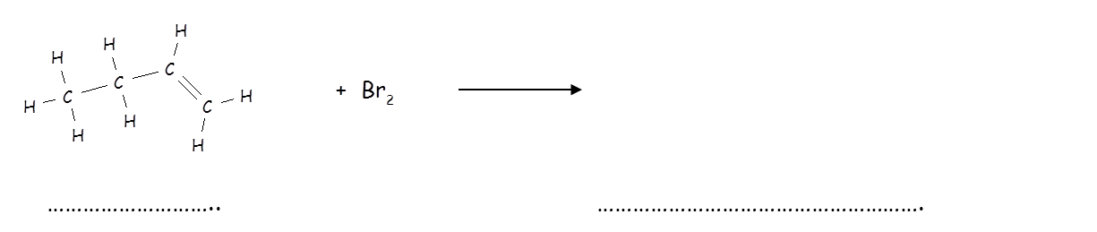**  
   NB test for unsaturation - the orange-red colour of the bromine solution disappears as the product, 1,2-dibromobutane is colourless.
2. **Addition of hydrogen halides**

+HCl

+HCl

propene

1. **Addition of water (______________)**



+ H2O

+ H2O