National 5 Unit 2: Nature’s Chemistry
Summary Quiz 2: Everyday Consumer Products
Alcohols (alkanols)
Complete:
Name of Homologous series - |  | General formula -
Name | Molecular formula |  | Structural formula
methanol
 |  |  | 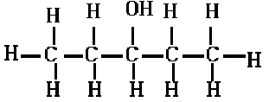
butan-1-ol
 |  |  | 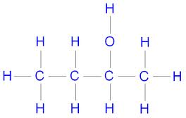

What is the name and structure of the functional group found in the alkanols (alcohols)?

Apart from use as in drinks and as a solvent, what is a common use of alcohols?

What properties allow them to be used as such?

Carboxylic acids
Name of Homologous series - |  |  | General formula -
Name | Molecular formula | Structural formula
ethanoic acid
 |  | 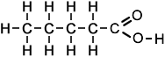
propanoic acid
 |  | 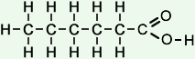

What is the name and structure of the functional group found in the carboxylic acids?

Ethanoic acid is more commonly known as what?

Aside from as a food product, what is vinegar used for?

Esters
Esters are made by reacting which two types of compound?

Give 2 uses for esters

